**Wynne’s Tours**

**Software User Manual**

**Group 36**

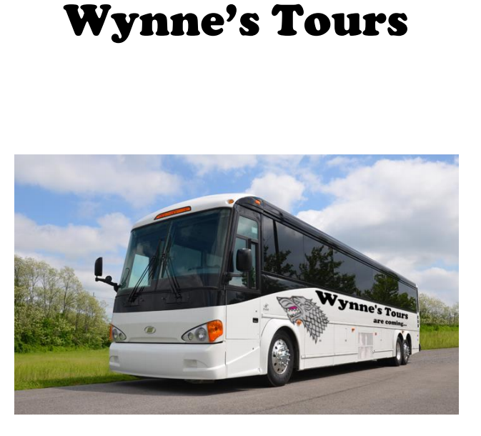

Introduction

Welcome to Wynne’s tours. This sophisticated software will suit your every need and help take your business above the rest. Below you will find all the instructions you will need to navigate through the software, what the capabilities of the software are and how to install it.

Installing the software

For this software there is no installation required all you need to do is copy the programs executable and associated files to a location on your computer and run it from there.

Getting started

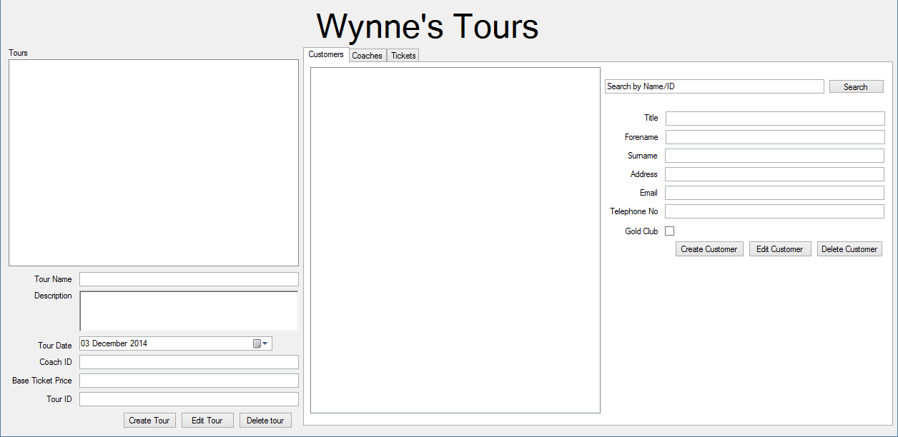

Once you have installed the program to your computer you will need to know what to do next, firstly you will notice the User Interface is very simple and pleasant to observe. Im going to split the form into two parts to make it easier to describe.

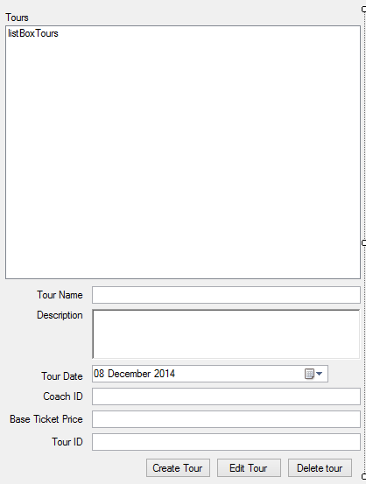

On the left hand side of the form you will find all the details about the tours, where you can create new tours, edit tours and delete excisting tours. The top of the form will display all the existing tours in a list. The rest of the form is quite self explanitary to add a new tour, The user will have to input the tour name, and description, choose a date on which the tour will take place, and the price of the tickets. The tour ID will be generated but the user will have to input the Coach ID, to get this you will have to look at the other half of the form, under the Coaches tab and if there are no existing coaches to link to the tour you will have to create a new one before you create a tour. To edit or Delete a tour, the user will have to select a Tour from the list above, and ammend as you see fit.

**Tickets**

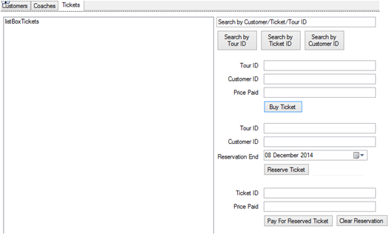

On the right hand side of the form you will see specific details of individual contributors of the tour. At the top of the form you will be able to search for a specific tour, to check if there is any tickets left for that tour, you can search for specific tickets, if a customer has already reserved the ticket and wants to pay for the rest. And finally you can search by specific customers which allows you to reserve tickets or clear reservations for that specific customer. The box on this side of the form will show all the existing data for which ever ID you have searched, you will have to find the ID of specific items to buy/reserve tickets.

**Customers**

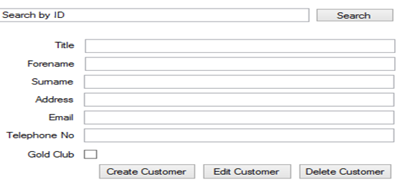

When on the customers tab you will see this interface on the form, this allows you to search the database for the customer, and a box will display the existing customers. You can select a customer from this list to edit or delete this customer. Or enter the details for the customer individually, to then create the customer by pressing the ‘Create Customer’ button. If the customer is a gold member then this can be changed by editing the customer with using the edit customer button when the gold customer box is ticked.

**Coaches**

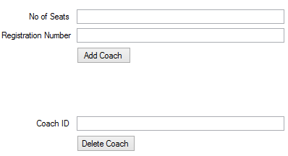

Finally this interface will be displayed if you select the Coaches tab, you will be able to add a new coach by inputting the registration number and the number of seats the coach has. Or delete a coach from the system by inputting the coach ID or selecting the coach from the list, all the existing coach details will be displayed in the box next to this.

Capabilities of the software

When using this software you will be able to add, edit and delete customers, selecting if they are part of the Gold club, subjecting them to discounts and other benefits. The software will also allow you to add and delete coaches, it will let customers buy/reserve tickets. And finally it will allow you to add new tours, edit and delete existing tours.

Error reports

If there is an error in the form, an exception will be thrown, and the program will display an error message, these will display the actual error, and would be more suited for someone who understands the language to see what the error does.